1️⃣ Equivalence Partitioning (EP)
Divide possible inputs into groups/classes where you expect the system to behave similarly.
Then test one representative value from each group.
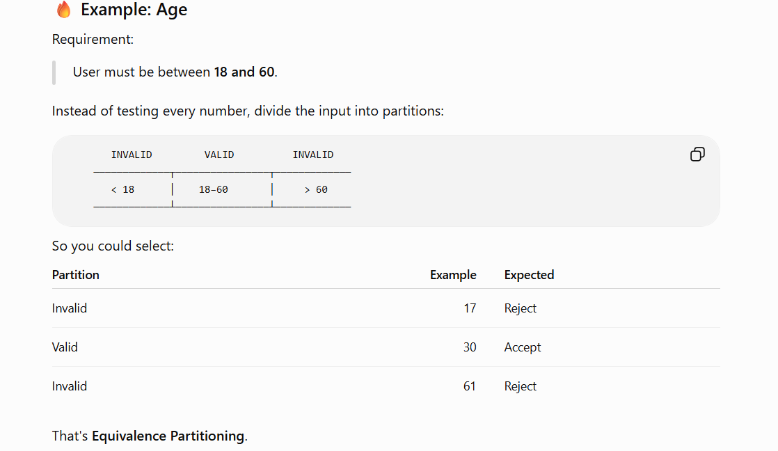
2️⃣ Boundary Value Analysis (BVA)
BVA says:
Bugs love boundaries.
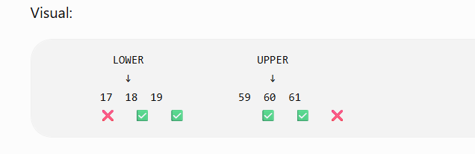
"What happens at the edges of those groups?
3️⃣ Decision Table Testing :
Now things get interesting because different combinations produce different outcomes.
A decision table helps organize this.
Conditions:
Username correct
Password correct
Account active

The output depends on multiple conditions/combinations.
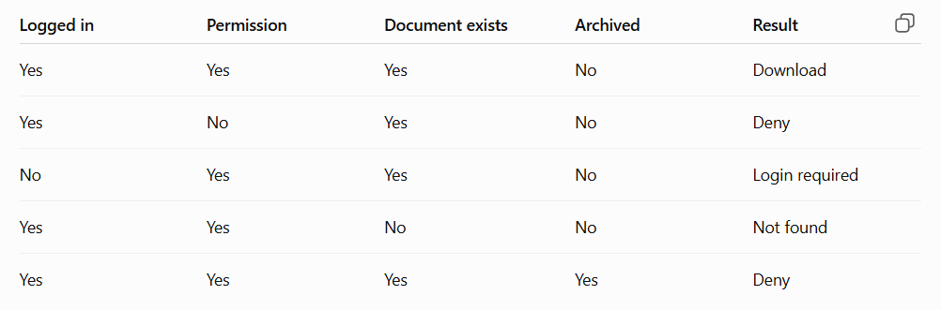
4️⃣ State Transition Testing
Now we're dealing with states.
The system behaves differently depending on what happened previously.

